# Groundwater Impact Scan

## Introduction

Groundwater is by far the largest source of fresh water available for human use, providing drinking water, irrigation, and water for industrial purposes. This resource is particularly important in relatively dry regions where surface water is scarce.

The demand for fresh water is increasing globally due to population growth and economic development. Based on the current increase in water demand, an estimated two-thirds of the global population will experience water scarcity by 2025. In light of the increasing water demand and climate change, it is crucial to ensure that groundwater resources are managed in a sustainable way.

However, assessing the potential negative impacts a proposed project can have on groundwater resources is not straightforward. Part of the difficulty is that groundwater is not visible and tends to respond slowly to changes. The Groundwater Impact Scan (GRIS) has been developed to address this issue. The scan uses global data and project characteristics to evaluate project-specific threats related to groundwater resources.

## Extra info for specific questions

### Groundwater use

Groundwater is an important source of fresh water. Wells are used to access and extract groundwater for drinking water, irrigation water or industrial purposes. These wells come in different shapes and sizes, each designed specifically for the location and the intended use.

Groundwater use can be explicit when new wells are planned as part of the project. However, when mains water is largely supplied by groundwater, projects using mains water should also be taken into consideration here.

### Land use change

The rate at which groundwater is replenished is partly controlled by the land cover. Areas with hard surfaces, like built up area, prevent rain or surface water from reaching the groundwater. Wetland and flooded areas, on the other hand, are usually characterized by high groundwater recharge rates. Other land cover types like cropland, grassland and bare surface fall in between these extremes.

From a groundwater quantity perspective, higher replenishment rates have a positive impact on groundwater resources due to the higher availability. From a groundwater quality perspective, on the other hand, higher replenishment rates increase the chance that contaminants at the surface reach the groundwater. Therefore, substantial changes in land cover type are important to assess potential impacts on groundwater resources.

For the purpose of this tool, we suggest any changes in land cover larger than approximately 5 hectares (~12 acres) are relevant for the risk assessment.

### Does the project include measures that slow or retain surface water?

The slower surface water moves, the greater the potential for surface water to make its way to groundwater. While infrastructure or measures that slow or store surface water have a positive effect on groundwater availability, they also make groundwater more vulnerable to any contaminants present in the surface water.

Examples of measures that slow or retain surface water include (check) dams, infiltration ponds or reservoirs, irrigation channels and other channel modifications.

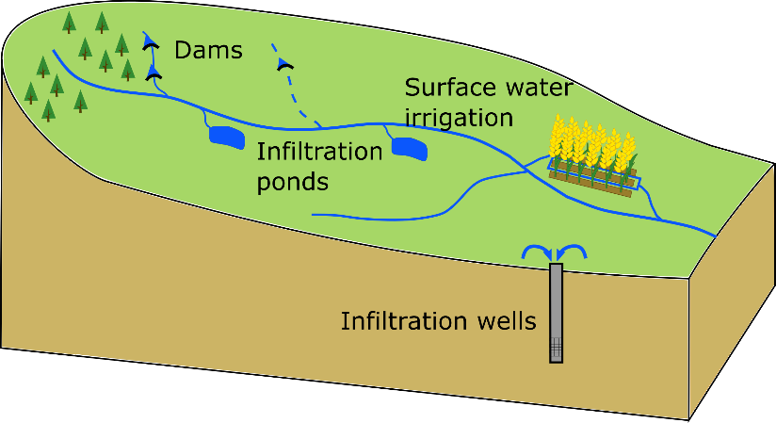

### Waste

While natural causes are responsible for some contaminants in groundwater, most groundwater contamination is caused by human activity. Waste materials left untreated, either in solid or liquid form, can be transported through the soil with rain or surface water to reach the groundwater. In time, the concentration of contaminants may make the groundwater unsuitable for use.

Waste can be generated by different sectors. Domestic waste sources include untreated waste water, sludge from waste water treatment plants, and household waste. Agricultural waste includes fertilizers and pesticides on the soil surface or in the water drained from fields. Industrial waste can include wastewater, chemicals and oil.

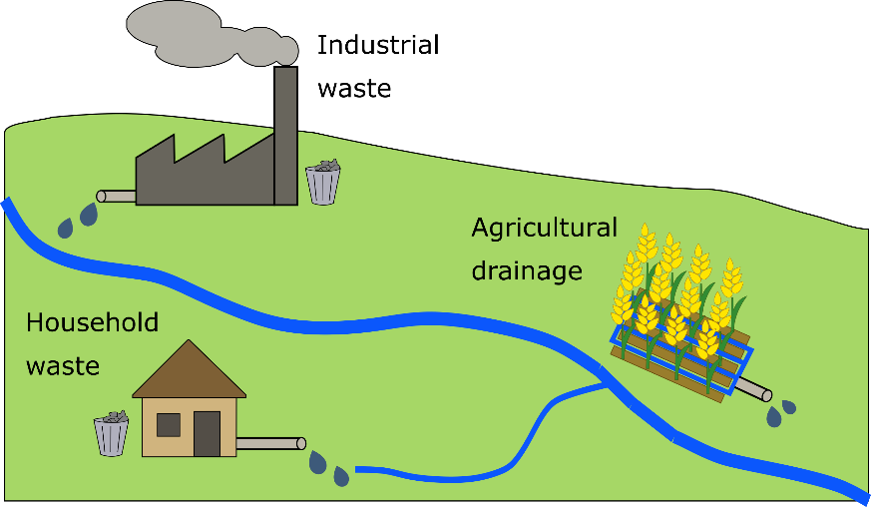

### Is the well shallow or deep?

The depth of the groundwater abstraction is related to the sustainability of the water use and the likelihood of groundwater contamination. Here, we distinguish two types of groundwater: shallow and deep groundwater.

Whether groundwater is shallow or deep is not related to a specific depth. Instead, we use the term shallow groundwater to describe the layer of groundwater closest to the surface. When groundwater is divided into different levels by layers of impermeable material, like clay, the lower levels considered to be deep groundwater.

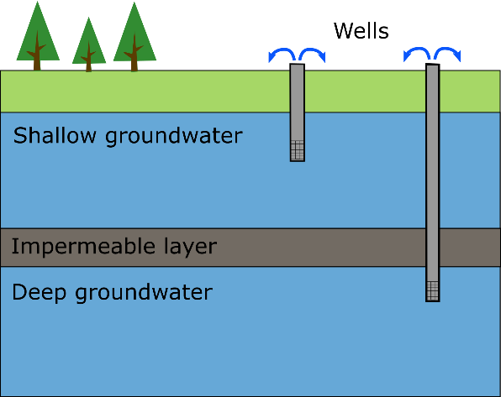

Deep groundwater may be plentiful, but is replenished much more slowly than shallow groundwater. Therefore, deep groundwater is more vulnerable to over-abstraction, where groundwater use is larger than recharge. In addition, pumping costs are higher when water is extracted from greater depths.

Shallow groundwater, on the other hand, is easier and cheaper to exploit. In addition, it is more likely to be replenished, although this does depend on the amount of rainfall and/or the availability of surface water in the region. The main risk in using shallow groundwater is that it is more vulnerable to contamination by human activities.

When information about which groundwater layer is being accessed is not available, we suggest using a depth of 100 meters (~300 feet) to differentiate between deep and shallow groundwater.

### Is the well planned in an urban or rural area?

Groundwater is more likely to be of poor quality in urban areas than in rural areas. The higher population density in urban areas increases the risk of biological pollutants. In addition, industrial and domestic waste are more concentrated. This means that it is extra important to check groundwater quality when wells are planned in urban areas.

## Indicators

### Recharge

An important measure of groundwater availability is groundwater recharge, or the amount of water transported through the soil to replenish the aquifer. Where groundwater recharge is high, a larger amount of groundwater can be extracted without negatively impacting groundwater availability. This indicator is based on average annual recharge data from the PCR-GLOBWB hydrological model.

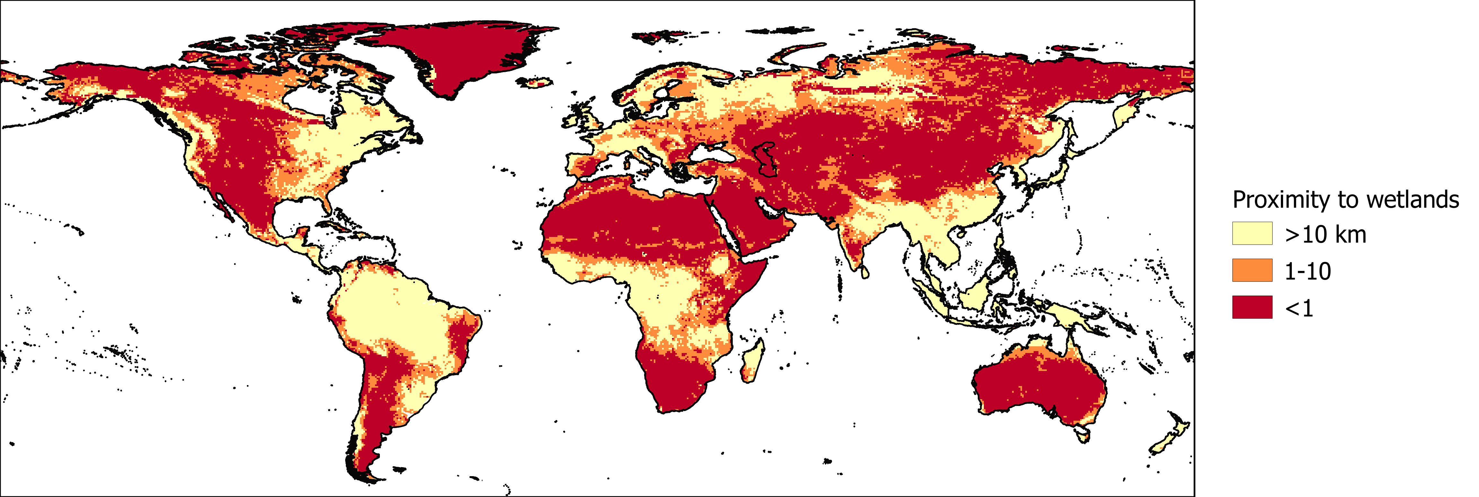

Map of modelled groundwater recharge divided into low (yellow), medium and high (red) risk categories.

Reference:

Wada, Y., Van Beek, L. P. H., Van Kempen, C. M., Reckman, J. W. T. M., Vasak, S., & Bierkens, M. F. P. (2010). Global depletion of groundwater resources. *Geophysical Research Letters*, *37*(20). https://doi.org/10.1029/2010GL044571

### Groundwater stress

Groundwater stress is calculated as the ratio between the amount of groundwater abstracted from the aquifer and the groundwater recharge. Where this ratio is larger than one, more water is used than is replenished in an average year. This means that groundwater use is not sustainable, and groundwater levels will recede over time. The groundwater footprint data is also used by WRI’s Aqueduct Water Risk Atlas.

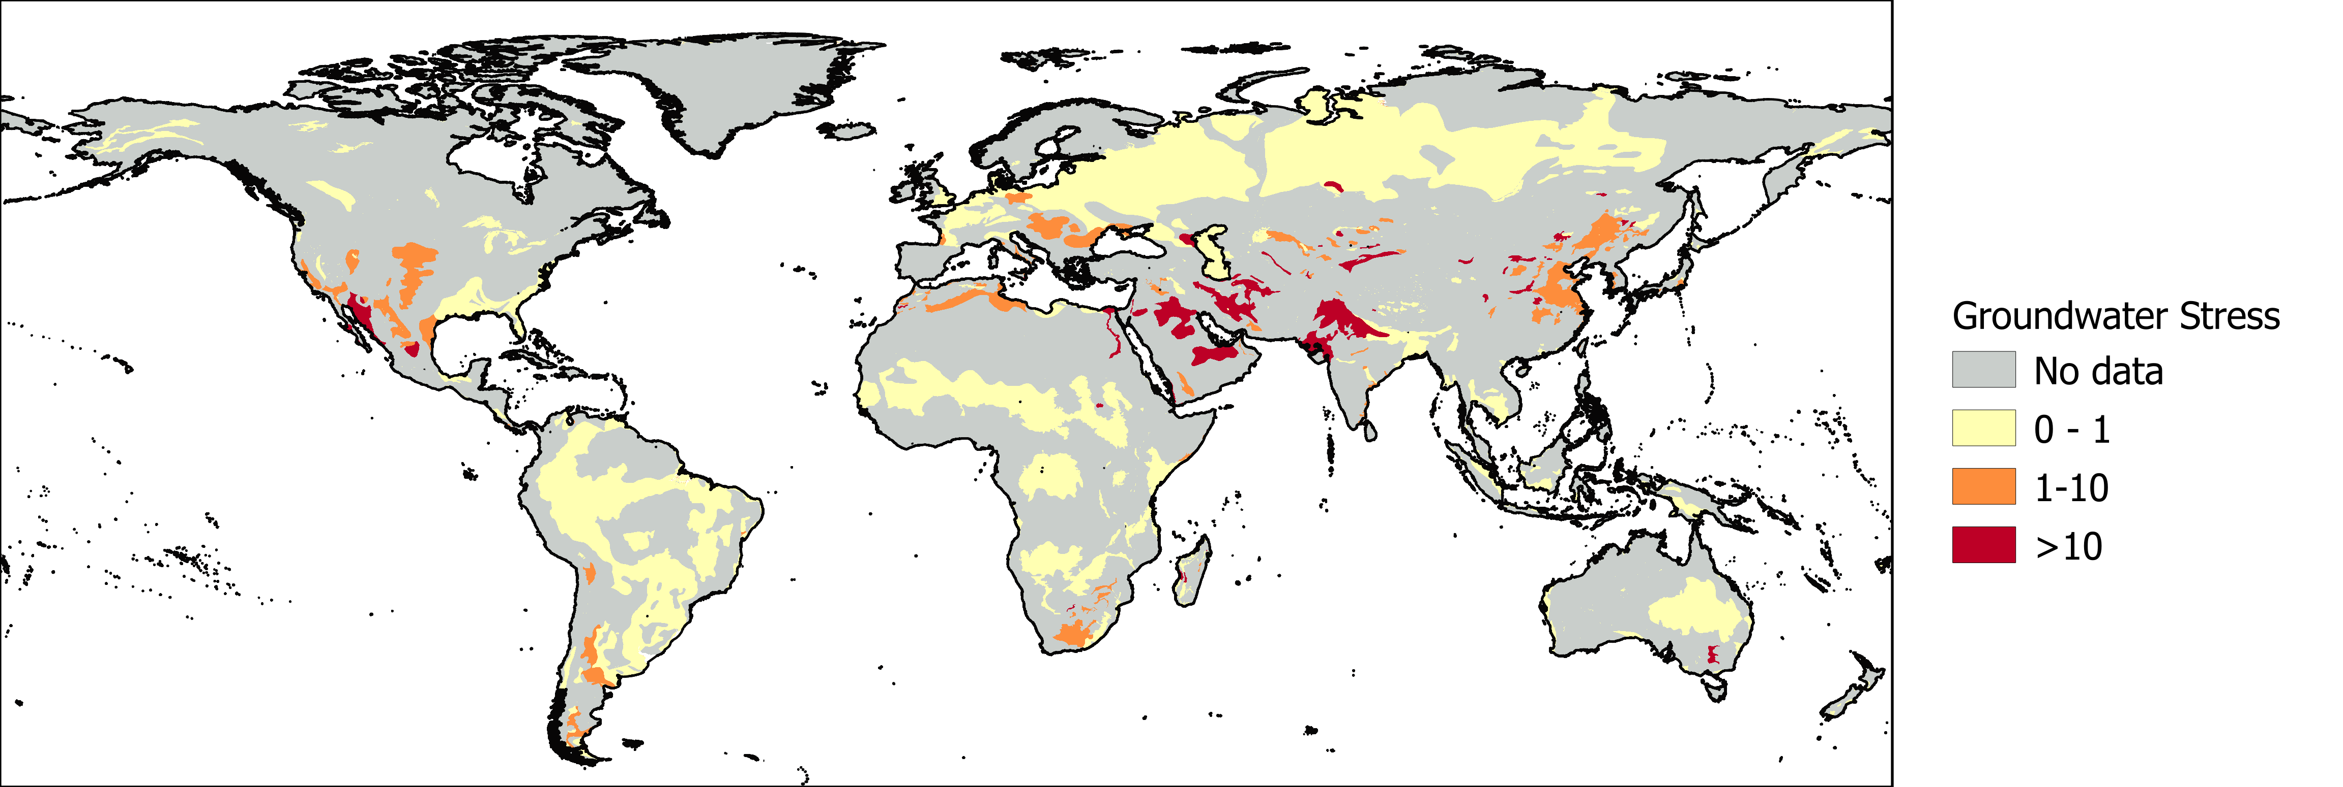

Groundwater stress, or the groundwater abstraction rate compared to the natural recharge rate, for a selection of aquifers divided into low (yellow), medium and high (red) risk categories.

References:

Gassert, F., Landis, M., Luck, M., Reig, P., & Shiao, T. (2013). “Aqueduct global maps 2.0.” Working Paper. Washington, DC: World Resources Institure. Available online at /publication/aqueduct-global-maps-20.

Gleeson, T., Moosdorf, N., Hartmann, J., & Van Beek, L. P. H. (2014). A glimpse beneath earth’s surface: GLobal HYdrogeology MaPS (GLHYMPS) of permeability and porosity. *Geophysical Research Letters*, *41*(11), 3891–3898. https://doi.org/10.1002/2014GL059856

### Population growth

Awareness of changes in groundwater demand in the future is needed to assess the sustainability of groundwater use. This is especially important in areas where groundwater resources are already under pressure. The population growth indicator is derived from the Shared Socioeconomic Pathways (SSP) Database. We use the relative increase in population expected between 2020 and 2050 under the SSP2 ‘middle of the road’ scenario assuming medium economic and population growth.

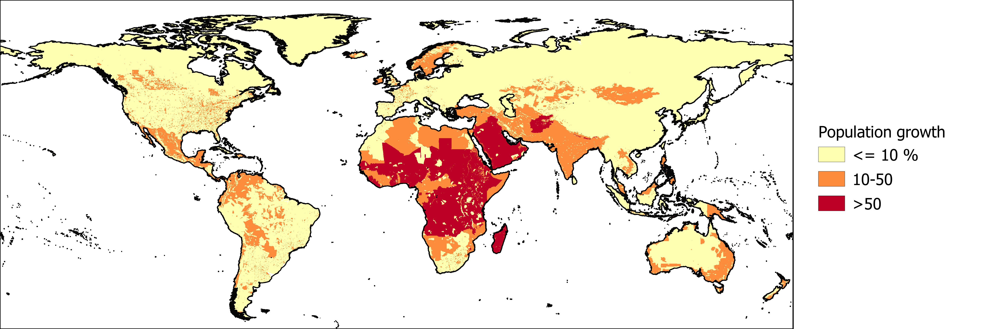

The population growth expected between 2020 and 2050 based on the SSP2 scenario, divided into risk low (yellow), medium, and high (red) risk categories.

Reference:

Jones, B., & O’Neill, B. C. (2017). Global Population Grids Based on Shared Socioeconomic Pathways (SSPs), 2010-2100. Palisades, NY: NASA Socioeconomic Data and Applications Center (SEDAC). doi:10.7927/H4RF5S0P

### Proximity to wetlands

Wetlands are sensitive ecosystems that play an important role in water purification, habitat provision and more. There is a strong link between groundwater and wetland areas, as wetlands can be fed by groundwater or act as a source of groundwater recharge. Groundwater abstraction near wetlands can affect the interaction between surface water and groundwater, and could for example cause wetlands to disappear. The Global Lakes and Wetlands Database was used to map wetland areas. We assigned risk categories based on the distance from these wetland areas.

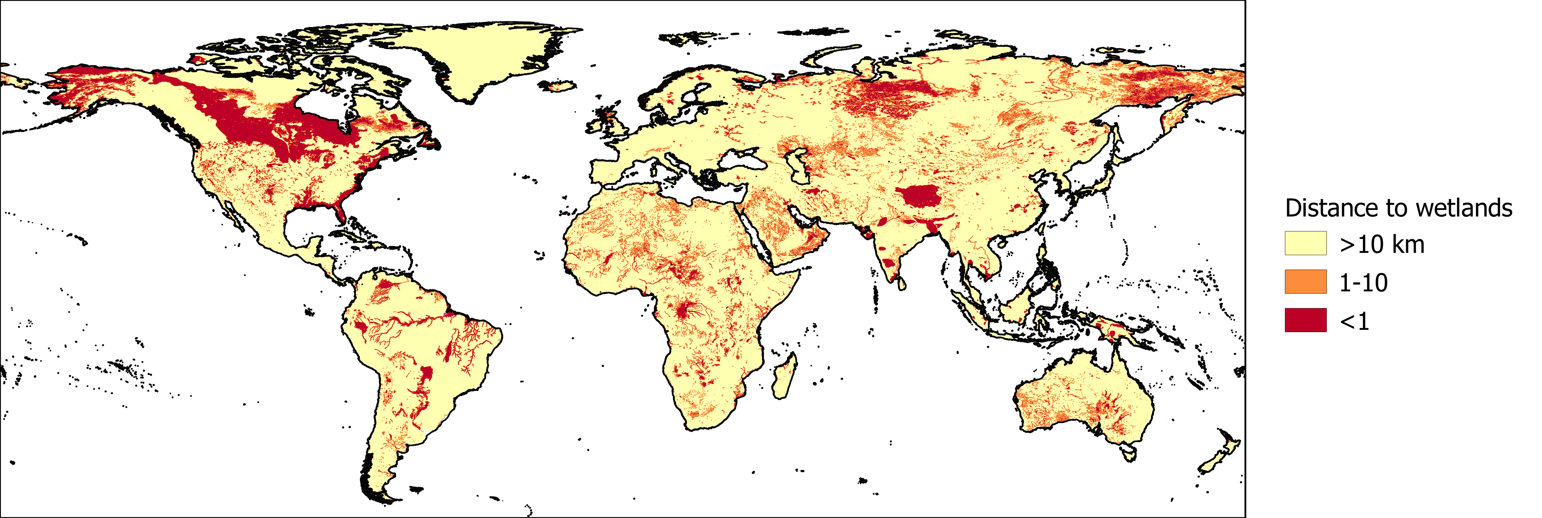

The distance to wetland areas divided into low (yellow), medium, and high (red) risk categories.

Reference:

Lehner, B., & Döll, P. (2004). Development and validation of a global database of lakes, reservoirs and wetlands. *Journal of Hydrology*, *296*(1–4), 1–22. https://doi.org/10.1016/j.jhydrol.2004.03.028

### Salinity

Saline or brackish groundwater may not be suitable for domestic or agricultural use without treatment. One potential source of salinity is the surrounding geology. The International Groundwater Resources Assessment Centre (IGRAC) provides a global dataset showing areas where groundwater is likely to be saline.

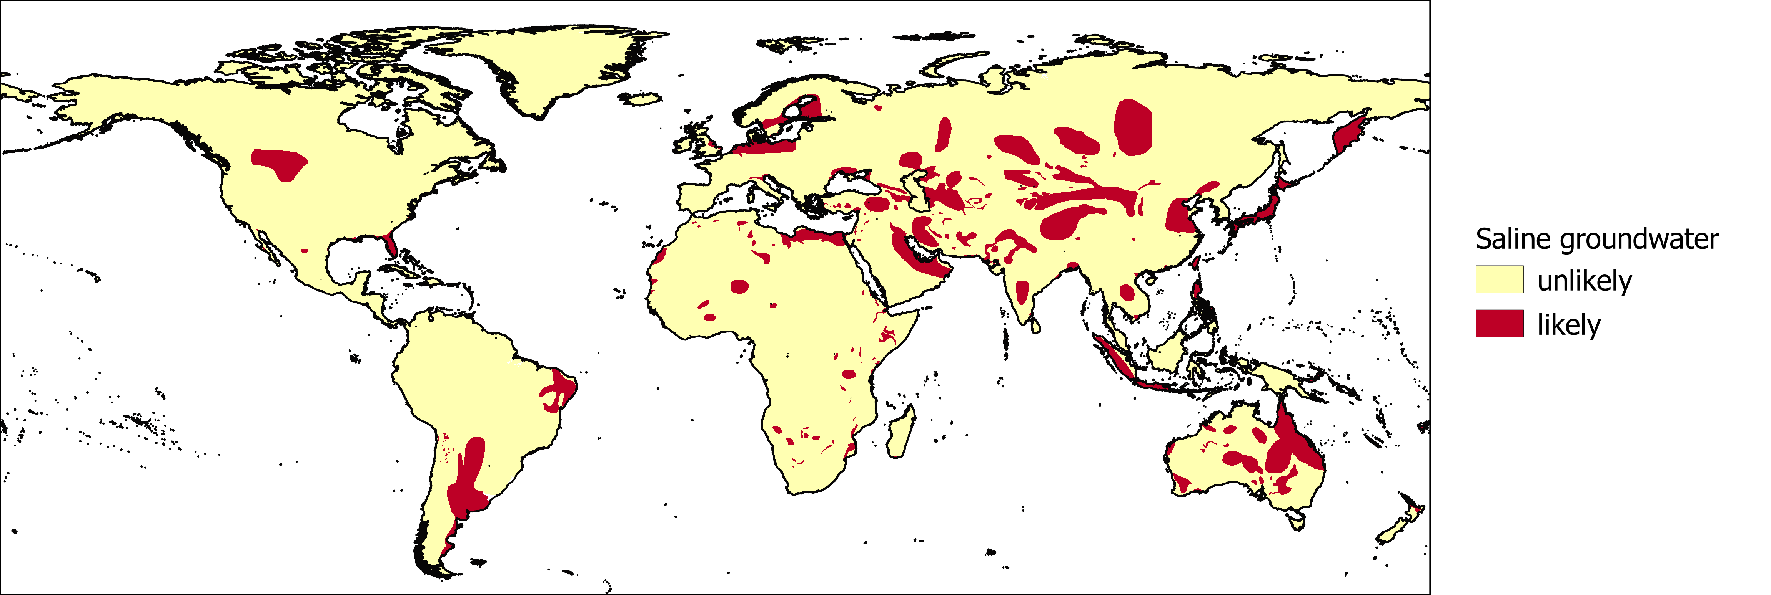

Map of the likelihood of saline groundwater.

Reference:

van Weert, F., van der Gun, J., & Reckman, J. (2009) Global overview of saline groundwater occurrence and genesis. IGRAC, Report nr GP-2009-1.

### Distance to the coast

Saline or brackish groundwater may not be suitable for domestic or agricultural use without treatment. Near coastlines, salt water from the ocean can intrude landwards. This is especially likely when groundwater is extracted. In the assessment, we assume that locations within 1 kilometer of the coast are high risk areas, and between 1 and 10 kilometers are medium risk areas.

### Arsenic

Elevated arsenic concentrations in groundwater are a potential health hazard if left untreated. The International Groundwater Resources Assessment Centre (IGRAC) gathers and provides information on the likelihood of excessive arsenic concentrations in groundwater.

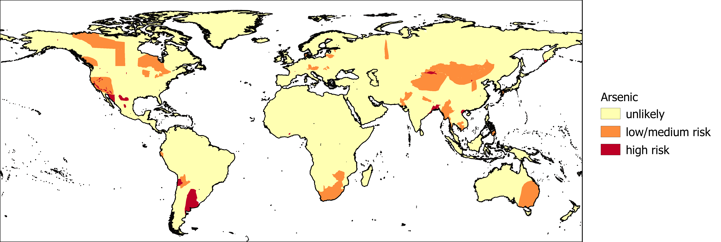

The likelihood of arsenic presence in groundwater.

Reference:

Brunt, R., Vasak, L., & Griffioen, J. (2004). Arsenic in groundwater: Probability of occurrence of excessive concentration on global scale. IGRAC, Report nr SP-2004-1.

### Fluoride

Elevated fluoride concentrations in groundwater are a potential health hazard if left untreated. The International Groundwater Resources Assessment Centre (IGRAC) provides information on the likelihood of excessive fluoride concentrations in groundwater.

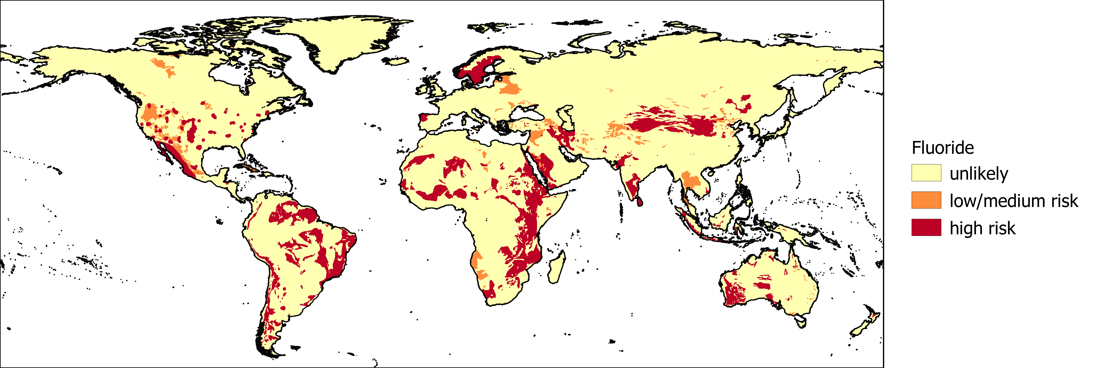

The likelihood of fluoride presence in groundwater.

Reference:

Brunt, R., Vasak, L., & Griffioen, J. (2014). Fluoride in groundwater: Probability of occurrence of excessive concentration on global scale. IGRAC, Report nr SP-2004-2.

### Aquifer vulnerability

Aquifer vulnerability indicates how likely contaminants and pollutants at the surface are to reach the groundwater. This depends on physical characteristics, such as the depth to the groundwater and the geology of the area. Usually, contaminants are transported to the groundwater by water moving through the soil. In general, the longer it takes for water to reach the groundwater, the lower the risk of groundwater contamination. This is because there is more opportunity for contaminants to be broken down, dispersed, or stick to the soil material along the way. Here, we applied a well-known method to calculate groundwater vulnerability called DRASTIC.

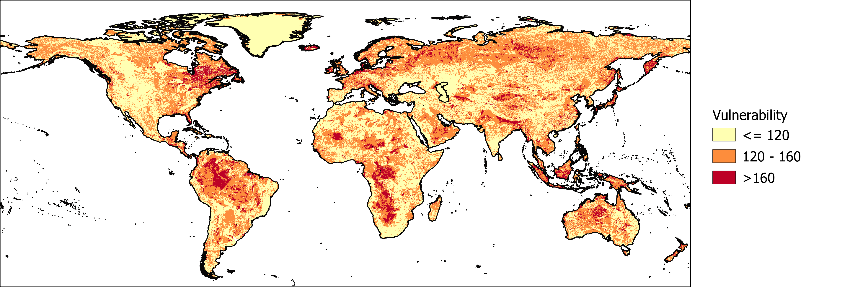

Global map of groundwater vulnerability based on the DRASTIC method, divided into low (yellow), medium and high (red) risk categories.

Note that whether contamination of vulnerable aquifers actually has an impact on groundwater use depends on the natural groundwater quality. Where groundwater is already of poor quality and is therefore not suitable for use, additional contamination may not have consequences for human activities.

**More about DRASTIC**

The DRASTIC method estimates aquifer vulnerability based on 7 datasets:

* Depth to groundwater
* Recharge
* Aquifer material
* Soil material
* Topography
* Influence of the vadose zone
* Conductivity

Each of these datasets is assigned a vulnerability value between 1 and 10 and a weight between 1 and 5. The vulnerability values and weights are combined to calculate a total score. Taking depth to groundwater as an example, the deeper the groundwater the lower the chance that a contaminant will reach the groundwater, and thus the lower the total vulnerability score. Depth to groundwater itself is also more important for overall groundwater vulnerability than topography, and therefore has a higher weight than topography.

The main limitation of this application at global scale is the lack of information about confining layers. A confining layer is a layer with a low permeability, or a low ability to transmit water. When one or more of these layers are located between the groundwater and the surface, the groundwater is much less vulnerable than when such a layer is not present. Ideally, the presence of a confining layer would be included in the influence of the vadose zone layer for DRASTIC, and would be indirectly related to other layers as well. Due to the lack of this data, the influence of the vadose zone is based on the soil material. As a result, the map overestimates groundwater vulnerability in areas that a confining layer is present.

References:

DRASTIC:

Aller, L., Bennett, T., Lehr, J. H., Petty, R. J., & Hackett, G. (1987). *DRASTIC : A Standardized Method for Evaluating Ground Water Pollution Potential Using Hydrogeologic Settings*. *NWWA/Epa-600/2-87-035*. doi:EPA/600/2-87/035

Depth to groundwater:

Fan, Y., Li, H., & Miguez-Macho, G. (2013). Global patterns of groundwater table depth. *Science*, *339*(6122), 940–943. doi:10.1126/science.1229881

Recharge:

Wada, Y., Van Beek, L. P. H., Van Kempen, C. M., Reckman, J. W. T. M., Vasak, S., & Bierkens, M. F. P. (2010). Global depletion of groundwater resources. *Geophysical Research Letters*, *37*(20). doi:10.1029/2010GL044571

Aquifer material:

Hartmann, J. & Moosdorf, N. (2012) The new global lithological map database GLiM: A representation of rock properties at the Earth surface. *Geochemistry, Geophysics, Geosystems*, 13 (12), Q12004. doi: [10.1029/2012GC004370](https://doi.org/10.1029/2012GC004370)

Soil data and Influence of the vadose zone:

FAO/IIASA/ISRIC/ISSCAS/JRC. (2012). Harmonized World Soil Database (version 1.2). FAO, Rome, Italy and IIASA, Laxenburg, Austria.

Topography:

Shuttle Radar Topography Mission v2

Conductivity:

Gleeson, T., Moosdorf, N., Hartmann, J., & Van Beek, L. P. H. (2014). A glimpse beneath earth’s surface: GLobal HYdrogeology MaPS (GLHYMPS) of permeability and porosity. *Geophysical Research Letters*, *41*(11), 3891–3898. doi:10.1002/2014GL059856

### Water Reuse Index

The Water Reuse Index is used as an indicator of surface water quality. Surface water quality can affect groundwater quality when significant amounts of contaminated surface water infiltrate and reach the groundwater. The Water Reuse Index is calculated by dividing the upstream non-consumptive water use by the available river discharge in an average year. Therefore, it represents how much of the available river discharge in an area consists of wastewater from upstream areas. When the value of the indicator is high, the area is more dependent on water treatment facilities to ensure adequate water quality than when the value is low. The return flow ratio was obtained from the Aqueduct Water Risk Atlas.

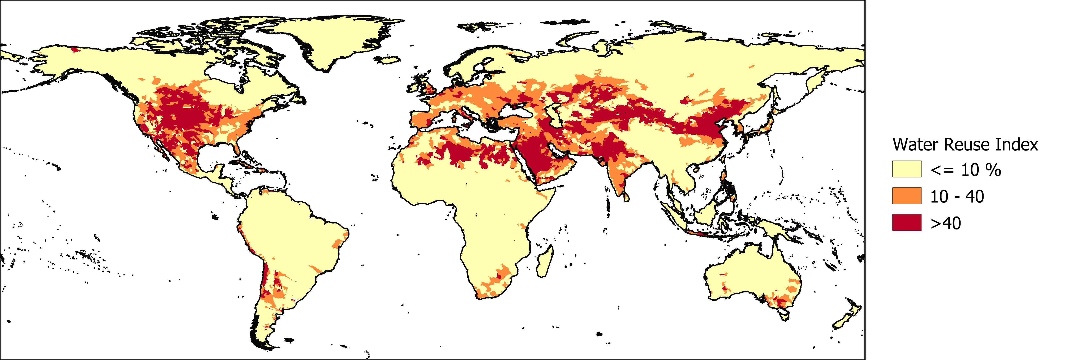

The Water Reuse Index, relating upstream water use to local water availability, classified into low (yellow), medium and high (red) risk categories.

Reference:

Gassert, F., Landis, M., Luck, M., Reig, P., & Shiao, T. (2013). “Aqueduct global maps 2.0.” Working Paper. Washington, DC: World Resources Institure. Available online at /publication/aqueduct-global-maps-20.